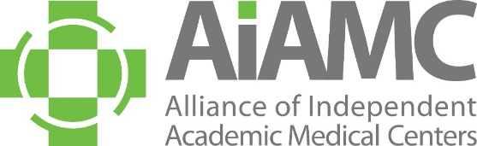

OFFLINE REGISTRATION FORM
2024 Annual Meeting
NI IX Meeting Two

Name:
Title:
Organization:
E-Mail:

Registration Fees: Annual Meeting

□ $1070 AIAMC Member Rate
□ $840 AIAMC National Initiative IX Participant Rate
□ $1195 Non-Member Rate
□ $330 Resident Member Rate – When accompanied by a paid member registration. The name of the paid member
from your institution is:
□ $540 Thursday Only Rate
□ $335 Friday Only Rate
□ $360 Saturday Only Rate
□ $65 Thursday Evening Reception GUEST Fee (No charge for meeting registrants) x ____ people
Guest Name:_________________________________
□ $110 Friday Night Annual Awards Dinner (per person) x ______ people
Guest Name:_________________________________

Please indicate the Annual Meeting optional pre-conference and conference breakout sessions you will attend.
(no charge but pre-registration is required):

Thursday, April 4th:

□ 8:00 am Pre-Conference Worship: Educator’s Forum
□ 10:00 am Pre-Conference Book Club
□ 11:00 am First-Time Attendees Luncheon

2:35 pm Concurrent Breakout Workshops -Select ONE of the following:
□ Introversion in Medical Education – Are There Implications for Assessment: Aurora Health Care
□ Lessons from the Redwoods: Fostering Team Connectivity and Innovation through Dynamic Dyad Leadership: JPS Health Network
□ Better Together: Harmonizing the Academic Model with Osteopathic Principles to Optimize Medical Education: OhioHealth

□ 4:00 pm AIAMC World Cafe’

Friday, April 5th:

10:40 am Concurrent Breakout Workshops -Select ONE of the following:
□ Teaching Hospitals and Medical Schools: Moving Beyond Affiliation Agreements to Impactful Strategic Partnerships: Guthrie/Robert Packer Hospital
□ Making the Case for a GME-Facilitated Population Health Clinic: Advocating Health Equity for Vulnerable Communities: OhioHealth
□ “What Do I Do Now?” An Educational Consult Service to Support Faculty And Program Directors With Complex Struggling Learners: OhioHealth

□ 4:00 pm Ben’s Bells Service Project

Registration Fees: National Initiative IX Meeting Two

□ $50 Team Leader
□ $300 Team Member (and additional team leaders)

□ $110 Friday Night Annual Awards Dinner (per person) x ______ people
Guest Name:_________________________________

□ 4:00 pm Ben’s Bells Service Project

Payment: □ American Express □ Visa □ MasterCard

Account #:
Amount: Exp. Date: CCID Code:
Billing Zip Code:

Send completed form to AIAMC Administrative Coordinator Mindi Apicella via email mindi@aiamc.org.
If you prefer to call-in your credit card information, Mindi’s direct line is 407.709.5520.
A receipt will be emailed to the address you provided above.

